Experiment No. 2
Signal Operations and Transformations
OBJECTIVE:
(i) To perform amplitude scaling and time scaling of continuous-time and discrete-time signals and analyze their effects on signal characteristics.
(ii) To perform addition and multiplication of two discrete-time sequences defined on different index ranges and analyze the resulting signal characteristics.
(i) AIM: To perform amplitude scaling and time scaling of continuous-time and discrete-time signals and analyze their effects on signal characteristics.
Software / Laboratory Environment: MATLAB
Theory
For a base signal x(t) (or x[n]), amplitude scaling changes only the vertical axis, while time scaling changes the horizontal axis. Compression (a > 1) squeezes the waveform and raises its frequency; expansion stretches it and lowers its frequency. In discrete time the independent variable is an integer, so x[2n] discards every second sample and x[n/2] must be filled with zeros at the odd indices.
Operation | Continuous time | Discrete time | Effect on the signal
Amplitude scaling | y(t) = A·x(t) | y[n] = A·x[n] | Amplitude × A; period / time axis unchanged
Time compression | y(t) = x(at), a > 1 | y[n] = x[an] (decimation) | Period T/a; discrete case drops samples
Time expansion | y(t) = x(t/a), a > 1 | y[n] = x[n/a] (zero insertion) | Period a·T; discrete case inserts a−1 zeros between samples

Experimental Procedure
- Generate the base signal x(t) = sin(2π·5t) as an anonymous function so that x(2t) and x(t/2) are obtained by changing its argument.
- Apply amplitude scaling using A = 2.
- Apply time compression using x(2t).
- Apply time expansion using x(t/2).
- Plot the original and transformed signals individually and on common axes.
- Measure the amplitude, period and frequency of every signal from its zero crossings.
- Repeat the three operations for a discrete-time sequence x[n] and compare all results with the theoretical scaling relationships.
Algorithm
- Start. Create t = −1:0.001:1 and define x = @(t) sin(2π·5t); set A = 2.
- Compute yA = A·x(t), yC = x(2t) and yE = x(t/2).
- For each signal find indices where the value changes from negative to non-negative, interpolate the crossing times, take T = mean(diff(t_z)) and f = 1/T; record max(signal) as the amplitude.
- Define x[n] on n = −3:3. Compute 2x[n]; for x[2n] keep indices n_c = ⌈n_min/2⌉ … ⌊n_max/2⌋ and read x at position 2n_c − n_min + 1; for x[n/2] create a zero vector on n = −6:6 and place the samples of x[n] at the even indices.
- Plot Figures 1–3 (individual, common-axes and discrete plots), print the measurements and stop.
MATLAB Coding
% Experiment 2(i): Amplitude Scaling and Time Scaling (continuous and discrete time)
clc; clear; close all;

%% Continuous-time signals
dt = 0.001; t = -1:dt:1; % time vector
x = @(t) sin(2*pi*5*t); % base signal x(t) = sin(2*pi*5*t)
A = 2; % amplitude-scaling factor

yA = A*x(t); % amplitude scaling A x(t)
yC = x(2*t); % time compression x(2t)
yE = x(t/2); % time expansion x(t/2)

% Measure amplitude, period and frequency (rising zero crossings)
sig = {x(t), yA, yC, yE};
names = {'Original x(t)','Amplitude 2x(t)','Compression x(2t)','Expansion x(t/2)'};
for k = 1:4
s = sig{k};
idx = find(s(1:end-1) < 0 & s(2:end) >= 0);
tz = t(idx) - s(idx)*dt ./ (s(idx+1) - s(idx)); % interpolated crossing times
Tk = mean(diff(tz));
fprintf('%-18s Amax = %.4f T = %.4f s f = %.4f Hz\n', names{k}, max(s), Tk, 1/Tk);
end

% Figure 1: individual plots
figure(1);
subplot(2,2,1); plot(t,sig{1},'LineWidth',1.2); grid on; axis([-1 1 -1.2 1.2]);
title('Original x(t) = sin(2\pi\cdot5t)'); xlabel('Time (s)'); ylabel('Amplitude');
subplot(2,2,2); plot(t,yA,'LineWidth',1.2); grid on; axis([-1 1 -2.4 2.4]);
title('Amplitude Scaling: 2x(t)'); xlabel('Time (s)'); ylabel('Amplitude');
subplot(2,2,3); plot(t,yC,'LineWidth',1.2); grid on; axis([-1 1 -1.2 1.2]);
title('Time Compression: x(2t)'); xlabel('Time (s)'); ylabel('Amplitude');
subplot(2,2,4); plot(t,yE,'LineWidth',1.2); grid on; axis([-1 1 -1.2 1.2]);
title('Time Expansion: x(t/2)'); xlabel('Time (s)'); ylabel('Amplitude');

% Figure 2: original and transformed signals on common axes
m = (t >= -0.5) & (t <= 0.5);
figure(2);
subplot(2,1,1); plot(t(m),sig{1}(m),t(m),yA(m),'LineWidth',1.2); grid on;
legend('x(t)','2x(t)'); title('Amplitude scaling on common axes');
xlabel('Time (s)'); ylabel('Amplitude');
subplot(2,1,2); plot(t(m),sig{1}(m),t(m),yC(m),t(m),yE(m),'LineWidth',1.2); grid on;
legend('x(t)','x(2t)','x(t/2)'); title('Time scaling on common axes');
xlabel('Time (s)'); ylabel('Amplitude');

%% Discrete-time signals
n = -3:3; xd = [1 2 3 4 3 2 1]; % x[n]
ydA = 2*xd; % amplitude scaling 2x[n]

nc = ceil(min(n)/2):floor(max(n)/2); % indices n for which 2n lies inside the range of x
ydC = xd(2*nc - min(n) + 1); % time compression x[2n] (every 2nd sample is kept)

ne = 2*min(n):2*max(n); % expanded index range
ydE = zeros(size(ne)); ydE(1:2:end) = xd; % time expansion x[n/2] (zeros at odd n)

fprintf('\n');
fprintf('%-15s: ', 'n (x[n])'); fprintf('%4d', n); fprintf('\n');
fprintf('%-15s: ', 'x[n]'); fprintf('%4d', xd); fprintf('\n');
fprintf('%-15s: ', '2x[n]'); fprintf('%4d', ydA); fprintf('\n');
fprintf('%-15s: ', 'x[2n], n=-1:1'); fprintf('%4d', ydC); fprintf('\n');
fprintf('%-15s: ', 'x[n/2], n=-6:6'); fprintf('%4d', ydE); fprintf('\n');

figure(3);
subplot(2,2,1); stem(n,xd,'filled'); grid on; axis([-7 7 -0.5 5]);
title('Original x[n]'); xlabel('n'); ylabel('Amplitude');
subplot(2,2,2); stem(n,ydA,'filled'); grid on; axis([-7 7 -0.5 9.5]);
title('Amplitude Scaling: 2x[n]'); xlabel('n'); ylabel('Amplitude');
subplot(2,2,3); stem(nc,ydC,'filled'); grid on; axis([-7 7 -0.5 5]);
title('Time Compression: x[2n]'); xlabel('n'); ylabel('Amplitude');
subplot(2,2,4); stem(ne,ydE,'filled'); grid on; axis([-7 7 -0.5 5]);
title('Time Expansion: x[n/2]'); xlabel('n'); ylabel('Amplitude');

Command Window Output
>> exp2_scaling
Original x(t) Amax = 1.0000 T = 0.2000 s f = 5.0000 Hz
Amplitude 2x(t) Amax = 2.0000 T = 0.2000 s f = 5.0000 Hz
Compression x(2t) Amax = 1.0000 T = 0.1000 s f = 10.0000 Hz
Expansion x(t/2) Amax = 1.0000 T = 0.4000 s f = 2.5000 Hz

n (x[n]) : -3 -2 -1 0 1 2 3
x[n] : 1 2 3 4 3 2 1
2x[n] : 2 4 6 8 6 4 2
x[2n], n=-1:1 : 2 4 2
x[n/2], n=-6:6 : 1 0 2 0 3 0 4 0 3 0 2 0 1

Input and Output Graphs
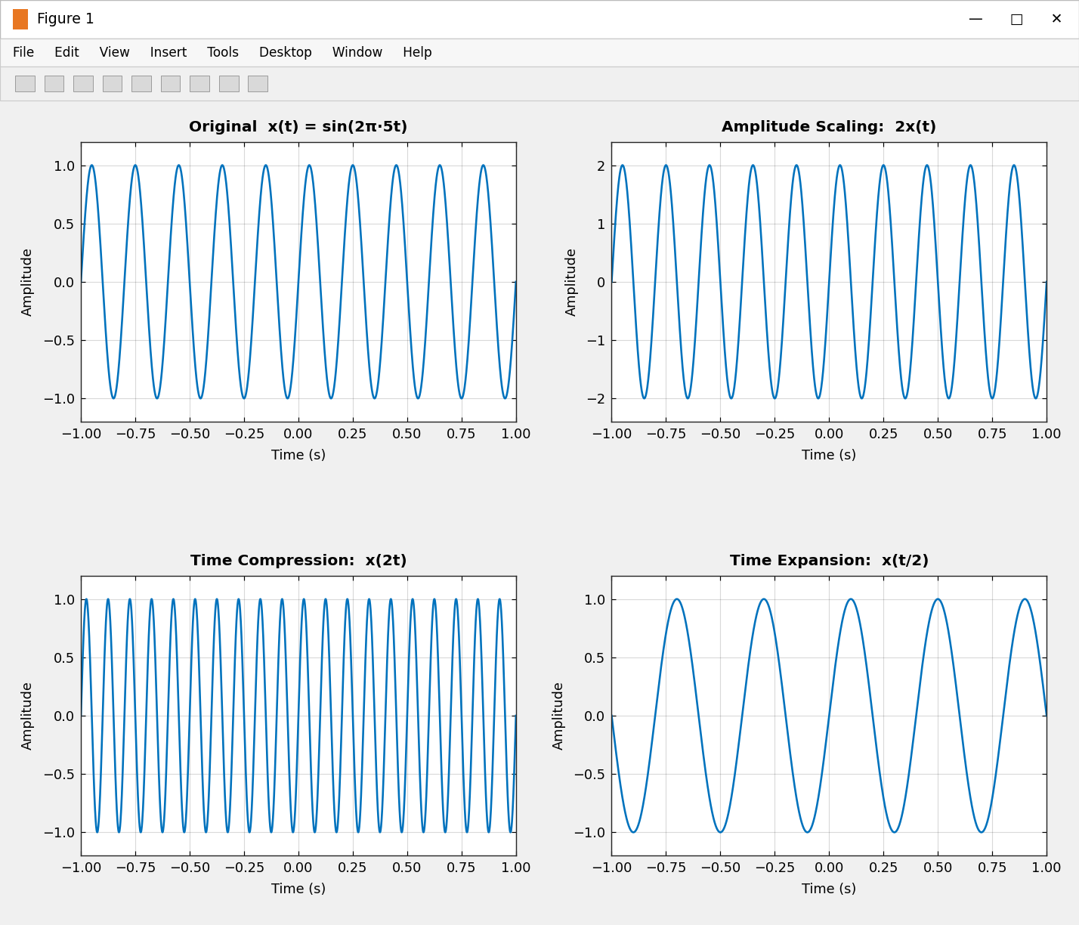
Figure 1: Continuous-time signal x(t) with amplitude scaling 2x(t), compression x(2t) and expansion x(t/2).
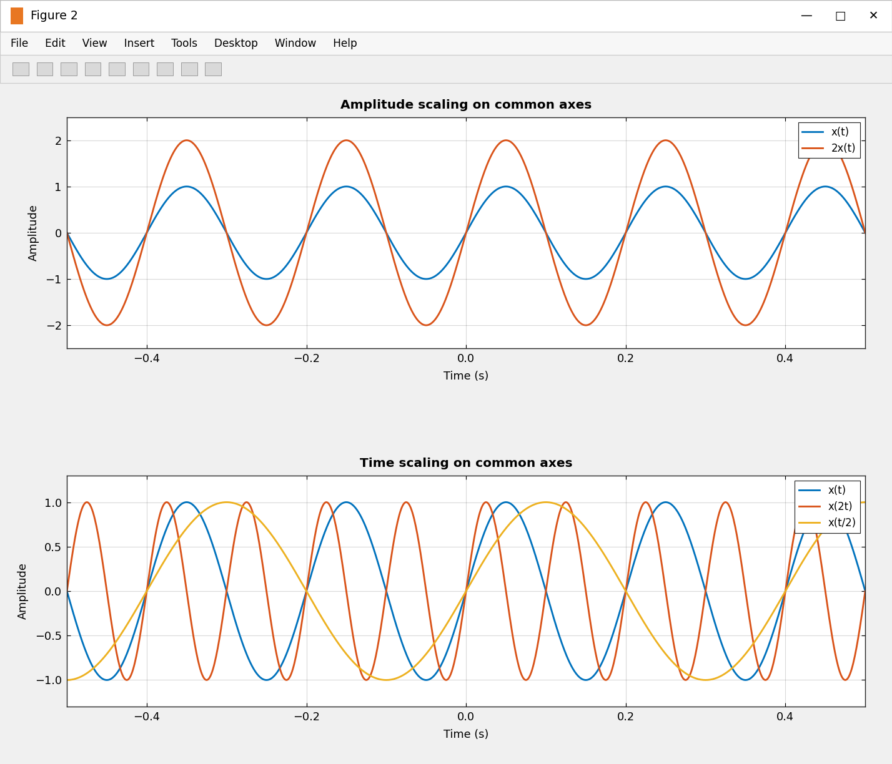
Figure 2: Original and transformed signals plotted on common axes (−0.5 s ≤ t ≤ 0.5 s).
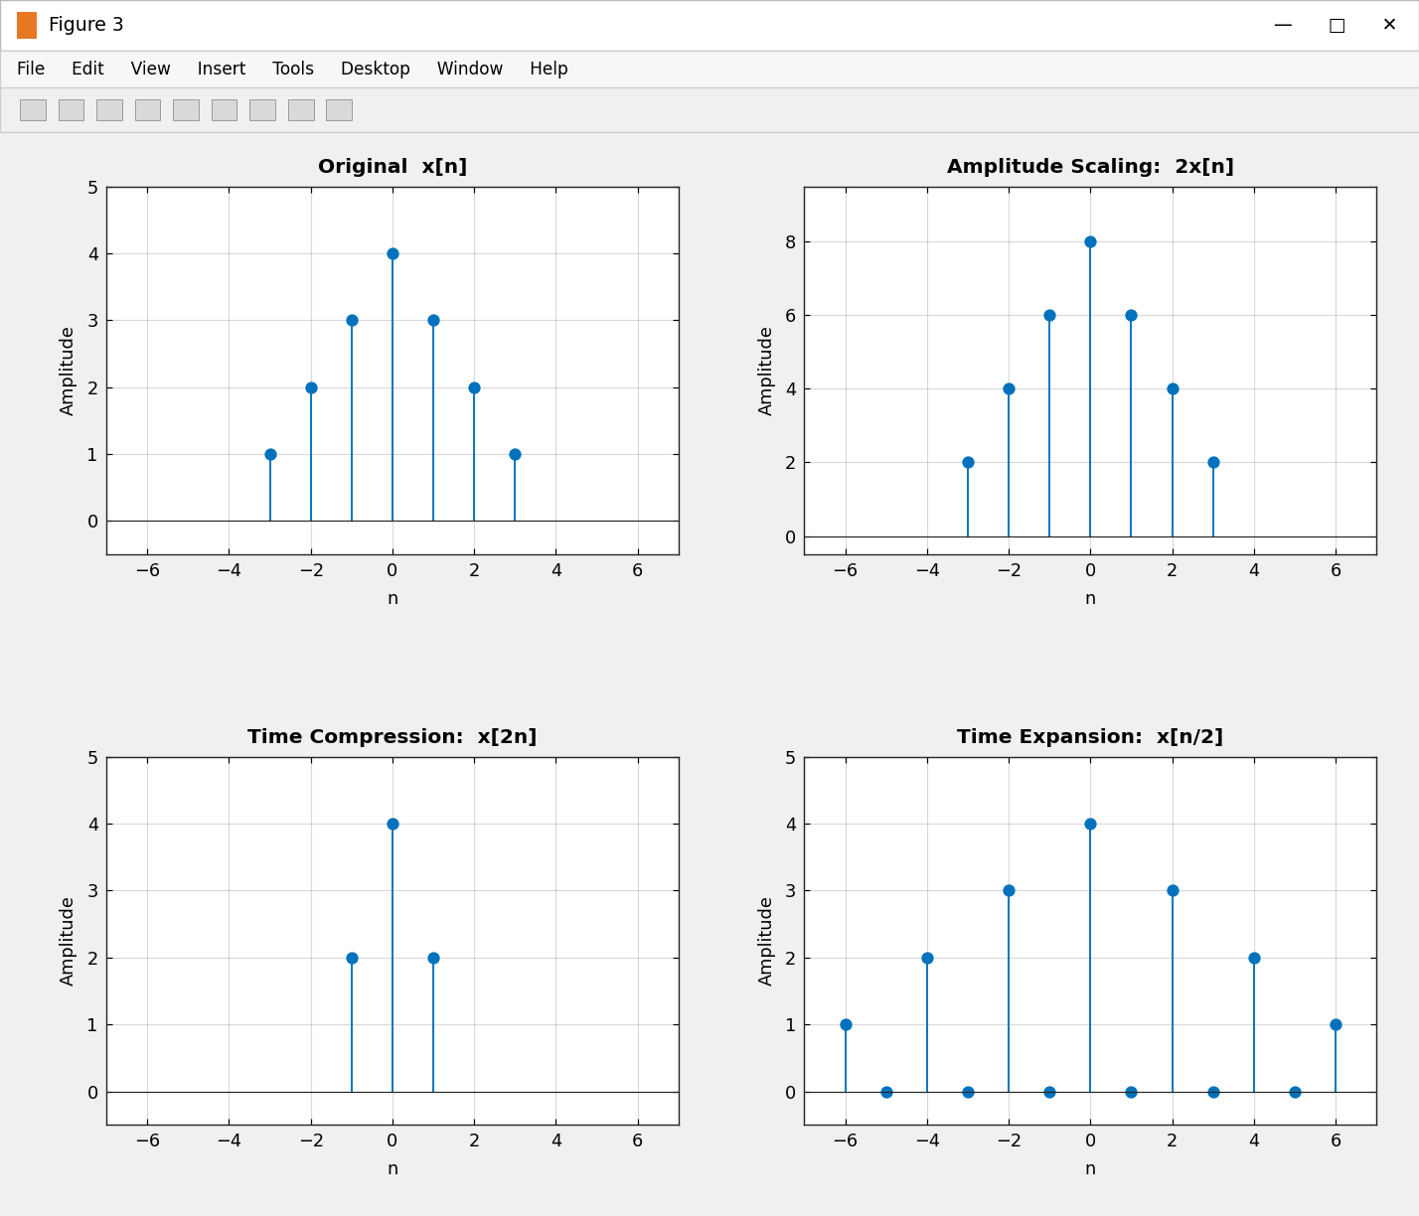
Figure 3: Discrete-time scaling – x[n], 2x[n], x[2n] and x[n/2].
Results
Signal | Amplitude (theory / measured) | Period (theory / measured) | Frequency (theory / measured)
x(t) = sin(2π·5t) | 1 / 1.0000 | 0.2 s / 0.2000 s | 5 Hz / 5.0000 Hz
2x(t) | 2 / 2.0000 | 0.2 s / 0.2000 s | 5 Hz / 5.0000 Hz
x(2t) | 1 / 1.0000 | 0.1 s / 0.1000 s | 10 Hz / 10.0000 Hz
x(t/2) | 1 / 1.0000 | 0.4 s / 0.4000 s | 2.5 Hz / 2.5000 Hz

Sequence | Samples (n = −3 … 3 unless stated) | Remark
x[n] | 1 2 3 4 3 2 1 | Triangular base sequence
2x[n] | 2 4 6 8 6 4 2 | All samples doubled
x[2n], n = −1 … 1 | 2 4 2 | Only even-indexed samples survive (information lost)
x[n/2], n = −6 … 6 | 1 0 2 0 3 0 4 0 3 0 2 0 1 | Zeros inserted between samples

Observations
- Amplitude scaling multiplies the peak value by 2 (1 → 2) but leaves the period (0.2 s) and frequency (5 Hz) unchanged.
- x(2t) completes the same cycle in half the time: the period falls to 0.1 s and the frequency doubles to 10 Hz.
- x(t/2) stretches the waveform: the period doubles to 0.4 s and the frequency halves to 2.5 Hz.
- In discrete time, x[2n] keeps only 3 of the 7 samples (information is lost), whereas x[n/2] doubles the length of the sequence by inserting zeros.
(ii) AIM: To perform addition and multiplication of two discrete-time sequences and analyze the resulting signal characteristics.
Software / Laboratory Environment: MATLAB
Theory
Addition and multiplication of sequences are carried out sample by sample at the same index n. When the two sequences are defined on different index ranges, both must first be extended with zeros to a common range, otherwise the vectors have different lengths and element-wise operations are meaningless.
Operation | Definition | Index handling | Typical use
Addition | z[n] = x[n] + y[n] | Pad both sequences with zeros to a common n | Mixing / superposition of signals
Multiplication | z[n] = x[n]·y[n] | Pad both sequences with zeros to a common n | Windowing, modulation

Experimental Procedure
- Define the sample indices n_x = −2:2 and n_y = 0:4 of the two sequences.
- Enter x[n] and y[n] and align them on the common index range by zero padding.
- Compute the sum sequence.
- Compute the product sequence using pointwise multiplication (.*).
- Plot the input and resulting sequences using stem plots.
- Compare the calculated samples with manual/theoretical results.
Algorithm
- Start. Read x[n] on n_x and y[n] on n_y.
- Form n = min(n_x(1), n_y(1)) : max(n_x(end), n_y(end)).
- Create zero vectors x1 and y1 of the same length as n; copy x into the positions where n belongs to n_x and y into the positions where n belongs to n_y (ismember).
- Evaluate z_sum = x1 + y1 and z_prod = x1 .* y1.
- Print the table, verify the results and plot Figure 4.
MATLAB Coding
% Experiment 2(ii): Addition and Multiplication of Two Discrete-Time Sequences
clc; clear; close all;

%% Sequences defined on different index ranges
nx = -2:2; x = [1 2 3 2 1]; % x[n]
ny = 0:4; y = [2 1 -1 1 2]; % y[n]

%% Align both sequences on a common index range (pad with zeros)
n = min(nx(1),ny(1)) : max(nx(end),ny(end)); % common range -2:4
x1 = zeros(size(n)); y1 = zeros(size(n));
x1(ismember(n,nx)) = x;
y1(ismember(n,ny)) = y;

%% Sample-by-sample operations
zSum = x1 + y1; % addition
zProd = x1 .* y1; % multiplication (element-wise)

fprintf('%-8s: ', 'n'); fprintf('%4d', n); fprintf('\n');
fprintf('%-8s: ', 'x[n]'); fprintf('%4d', x1); fprintf('\n');
fprintf('%-8s: ', 'y[n]'); fprintf('%4d', y1); fprintf('\n');
fprintf('%-8s: ', 'x+y'); fprintf('%4d', zSum); fprintf('\n');
fprintf('%-8s: ', 'x.*y'); fprintf('%4d', zProd); fprintf('\n');
fprintf('Sum of products sum(x.*y) = %d\n', sum(zProd));
fprintf('Energy of x[n]+y[n] = %d\n', sum(zSum.^2));
fprintf('Addition commutative? %d Multiplication commutative? %d\n', ...
isequal(x1+y1, y1+x1), isequal(x1.*y1, y1.*x1));

%% Plots
figure(4);
subplot(2,2,1); stem(n,x1,'filled'); grid on; xticks(n);
title('x[n]'); xlabel('n'); ylabel('Amplitude');
subplot(2,2,2); stem(n,y1,'filled'); grid on; xticks(n);
title('y[n]'); xlabel('n'); ylabel('Amplitude');
subplot(2,2,3); stem(n,zSum,'filled'); grid on; xticks(n);
title('Addition x[n] + y[n]'); xlabel('n'); ylabel('Amplitude');
subplot(2,2,4); stem(n,zProd,'filled'); grid on; xticks(n);
title('Multiplication x[n]\cdot y[n]'); xlabel('n'); ylabel('Amplitude');

Command Window Output
>> exp2_addmult
n : -2 -1 0 1 2 3 4
x[n] : 1 2 3 2 1 0 0
y[n] : 0 0 2 1 -1 1 2
x+y : 1 2 5 3 0 1 2
x.*y : 0 0 6 2 -1 0 0
Sum of products sum(x.*y) = 7
Energy of x[n]+y[n] = 44
Addition commutative? 1 Multiplication commutative? 1

Input and Output Graphs
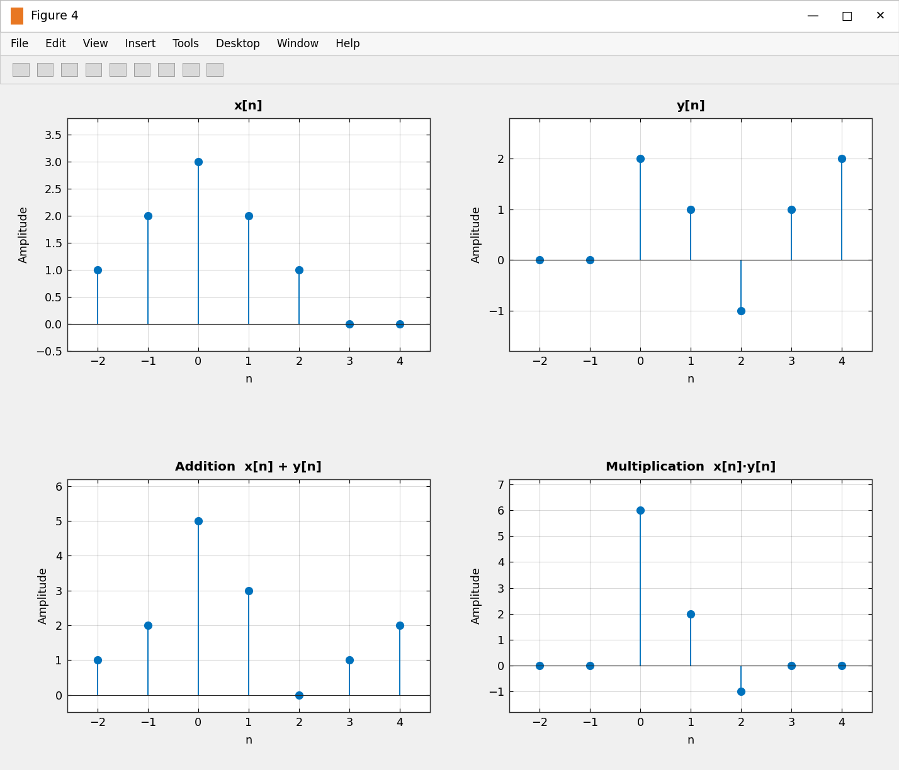
Figure 4: Input sequences x[n], y[n], their sum and their product on the common range n = −2 … 4.
Results
n | −2 | −1 | 0 | 1 | 2 | 3 | 4
x[n] | 1 | 2 | 3 | 2 | 1 | 0 | 0
y[n] | 0 | 0 | 2 | 1 | −1 | 1 | 2
x[n] + y[n] | 1 | 2 | 5 | 3 | 0 | 1 | 2
x[n]·y[n] | 0 | 0 | 6 | 2 | −1 | 0 | 0

Check | Manual / theoretical | MATLAB | Remark
z[0] = x[0] + y[0] | 3 + 2 = 5 | 5 | Match
z[0] = x[0]·y[0] | 3 × 2 = 6 | 6 | Match
Σ x[n]·y[n] | 0+0+6+2−1+0+0 = 7 | 7 | Match
Energy of x[n] + y[n] | 1+4+25+9+0+1+4 = 44 | 44 | Match

Observations
- After zero padding, both sequences occupy n = −2 … 4, so the operations are well defined at every index.
- The sum is non-zero wherever either sequence is non-zero (n = −2 … 4 except n = 2), whereas the product is non-zero only where both are non-zero (n = 0, 1, 2).
- The product at n = 2 is negative (1 × (−1) = −1) because y[2] is negative.
- Addition and multiplication are both commutative, as verified in MATLAB.
Conclusion
Amplitude scaling and time scaling of continuous-time and discrete-time signals were implemented and the measured amplitude, period and frequency agree with the theoretical relationships. Two sequences defined on different index ranges were aligned and successfully added and multiplied, and the results match the manual calculations.

